**TECHTROVEPC**

**PROPONENTS:**

Alalim, Christian Jake

Cabrera, Eda

Galvez, Rence

Segarra, Mark

Tuttuh, Alnur

Villarta, Mica

**INTRODUCTION**

TechTrovePC is an e-commerce platform designed to cater to tech enthusiasts and everyday users seeking high-quality electronic products, particularly desktops and laptops. The creation of this website was a collaborative effort by the group 1 of IP22. Our aim was to develop a dynamic, user-friendly website that not only showcases our extensive product range but also offers an engaging shopping experience for our customers.

Given our status as 12th-grade students, we focused on utilizing HTML, CSS, and JavaScript to build the TechTrovePC website. Each team member played a role, contributing their skills within these technologies. We worked tirelessly to ensure a seamless and interactive user interface, while our designer focused on creating an intuitive and visually appealing design. Content creation and design planning were carefully made to ensure that our offerings were both informative and engaging.

Despite the limitations of not using back-end technologies, we ensured that our site was functional, responsive, and provided a satisfying user experience. Throughout the development journey, time and task management were crucial to our success. Detailed planning and regular progress tracking ensured that we stayed on schedule and addressed any challenges promptly. Our documentation provides a comprehensive overview of the tasks, timelines, and team responsibilities that were integral to the project's success. By sharing our process, we aim to highlight the collaborative effort and amazing planning that went into creating TechTrovePC, showcasing our commitment and customer satisfaction.

**PROJECT SCOPE**

*1. Customer*

* Sign up: Users can create an account on the TechTrovePC website to access personalized features and make purchases.
* Log in: Registered users can log in to their accounts using their credentials.
* View Home Page: Customers can navigate to the home page to explore featured products, promotions, and announcements.
* View Shop Page: The shop page displays the complete range of electronic products available for purchase, categorized for easy browsing.
* View Services Page: Customers can access information about additional services offered by TechTrovePC, such as warranty options or technical support.
* View About Page: Users can learn more about the TechTrovePC team, mission, and values on the about page.
* View Contact Page: Customers can find contact information and reach out to TechTrovePC for inquiries or assistance.
* Dynamically interact on the products: Users can interact with product listings, view detailed descriptions, images, and add items to their cart for purchase.
* View Profile: Registered users can access their profile page after logging in.
* Checkout Page: Users can proceed to the checkout page once they have added desired items to their cart. Payment options should be available for users to complete the purchase securely. After successful payment, users should receive confirmation of their order.
* View Order History: Registered users can access their order history section from their profile. The order history page will display a list of past orders made by the user. Each order entry should include details such as order date, order number, items purchased, total amount, and current status.

*2. Admin*

* Access to Dashboard: Admin can log in using unique credentials provided via the login page.
* View Recent Orders: Admins can access a list of recent orders placed by customers, including order details and status.
* View Sales: The sales section provides insights into revenue generated over a specific period, including sales trends and performance metrics.
* View Comments: Admins can monitor and manage customer comments and reviews, including responding to feedback and addressing concerns.
* View Earnings: This section displays total earnings generated from sales, broken down by product or category.
* View Daily Views: Admins can track daily website traffic and visitor metrics to gauge site performance and user engagement.
* View Customers’ Status: Access to customer profiles and accounts, including order history, preferences, and account details.
* Manage Products: Admins can manage the products in Products tab.

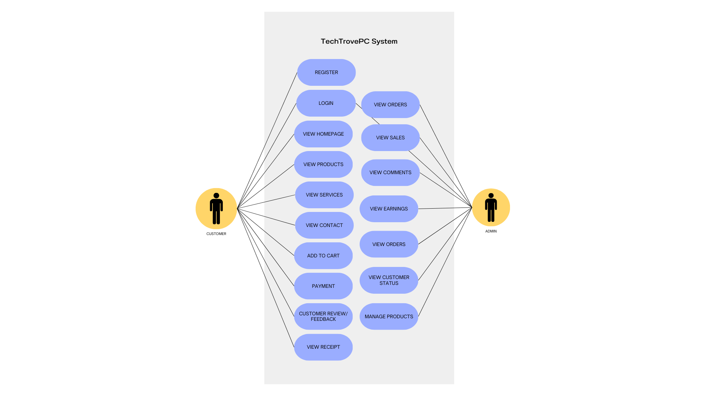**SYSTEM ARCHITECHTURE – USE CASE**

**UI DESIGN**

*Login & Sign Up*

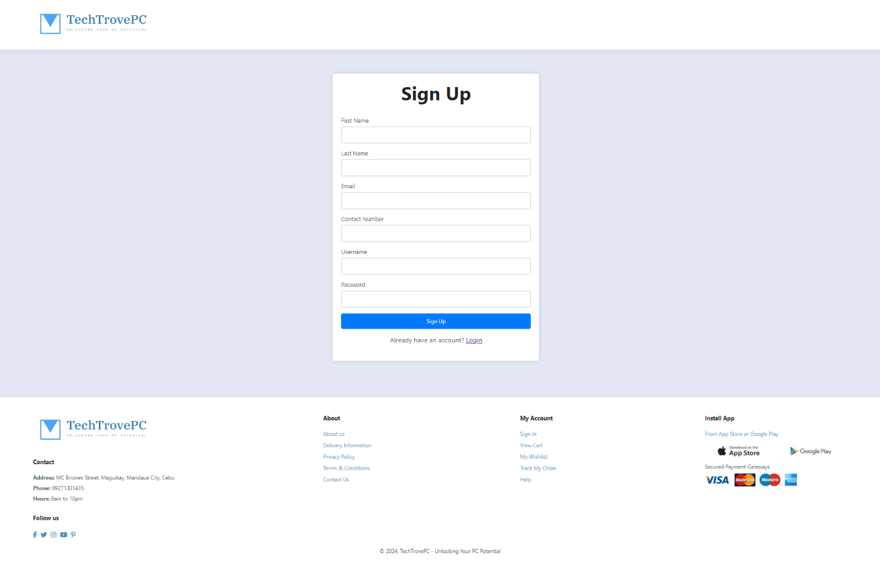

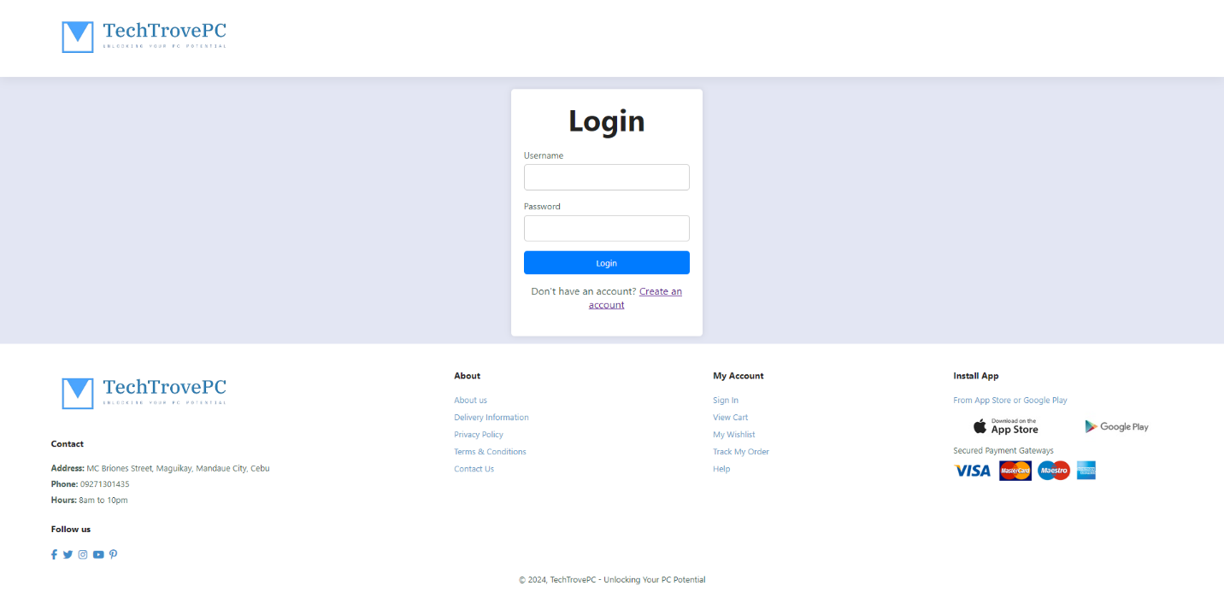

**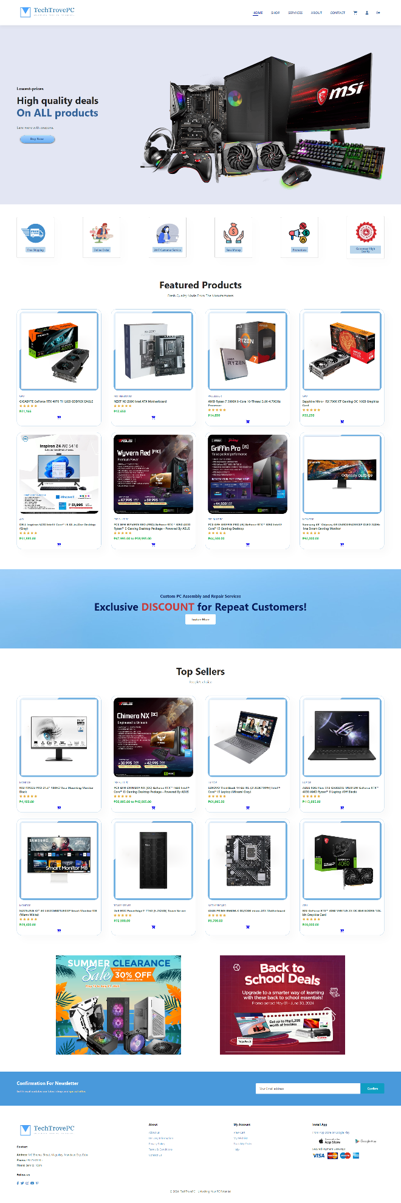***Home Page*

*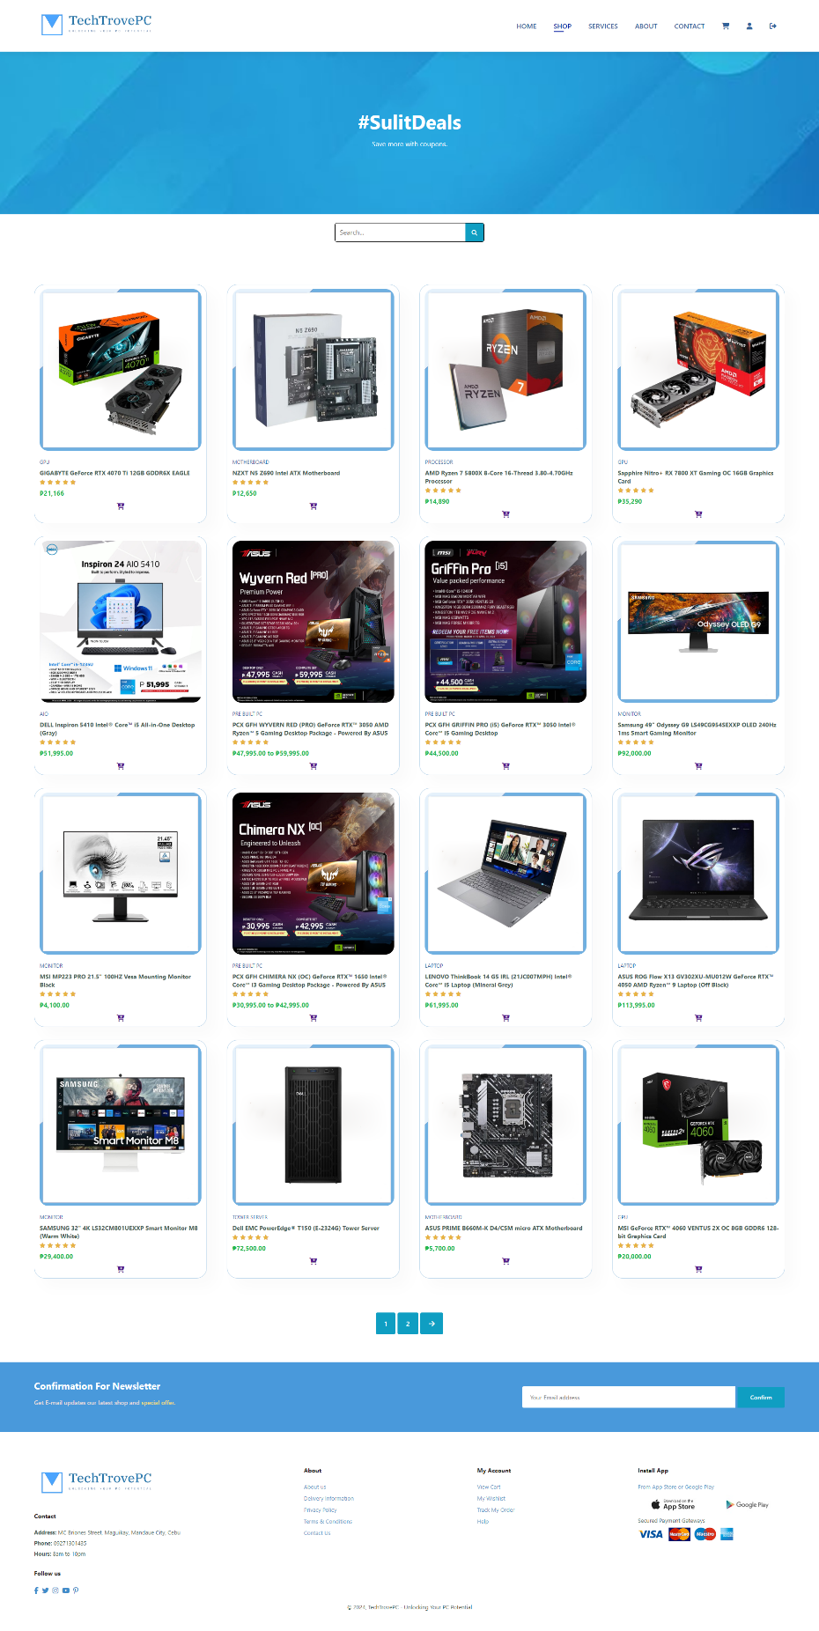Shop Page*

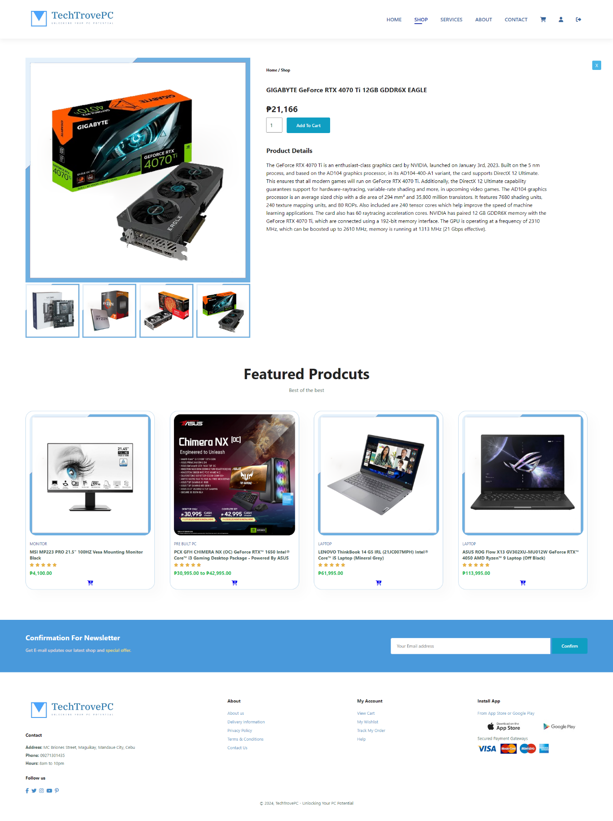

*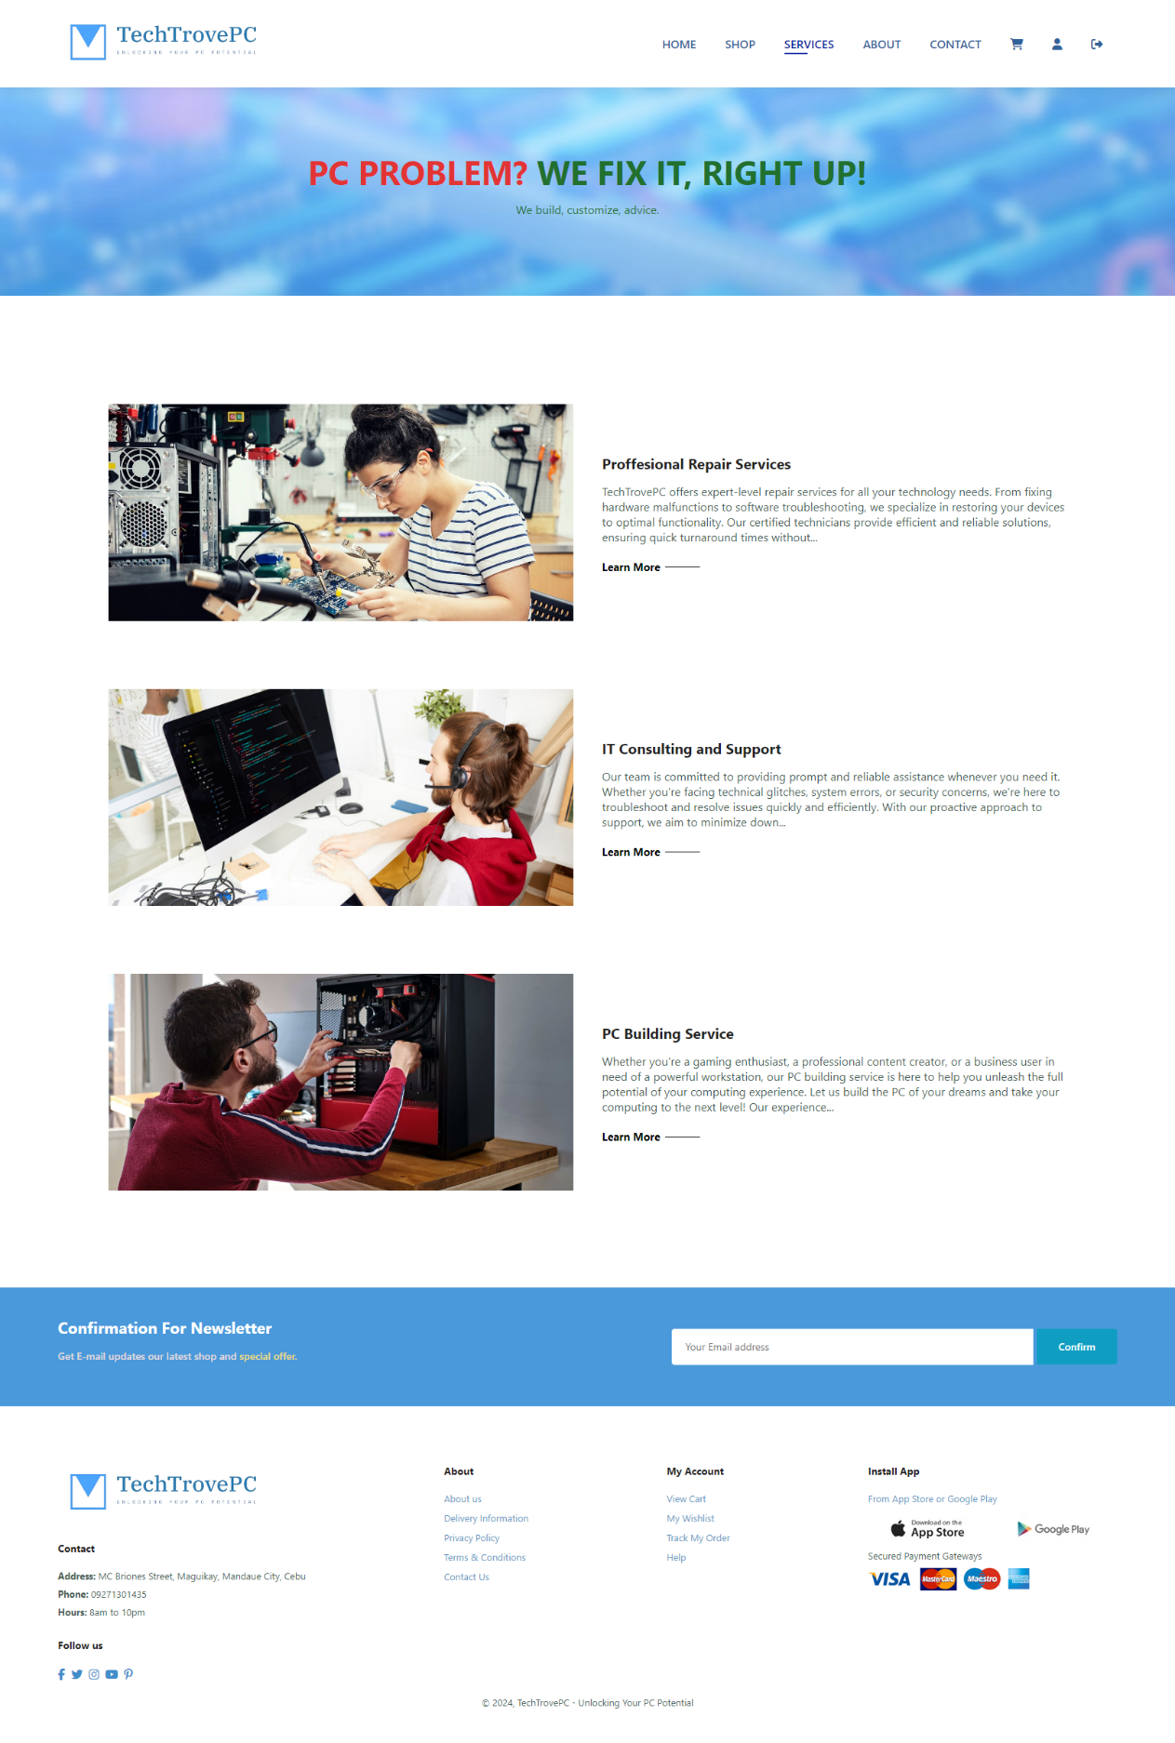Services Page*

*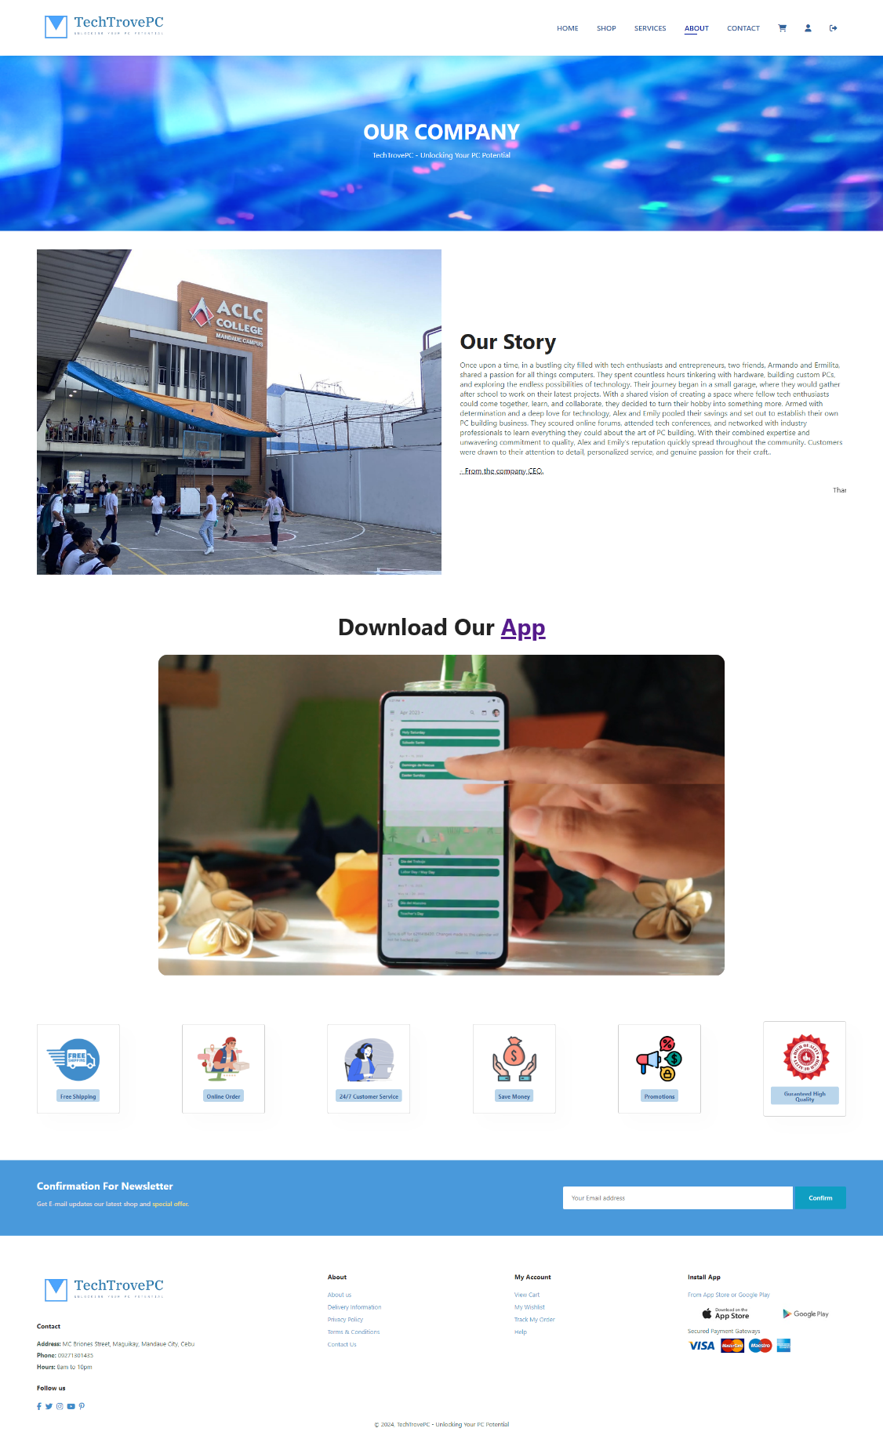About Page*

*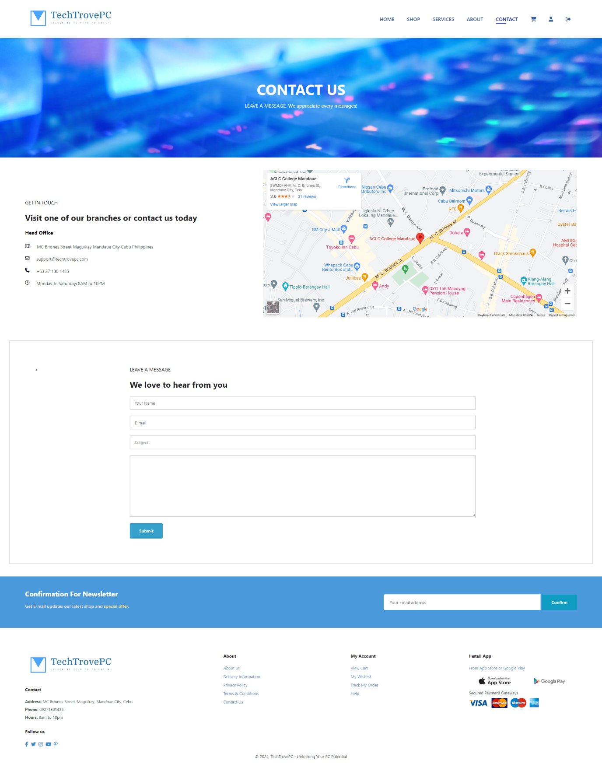Contact Page*

*Cart Page*

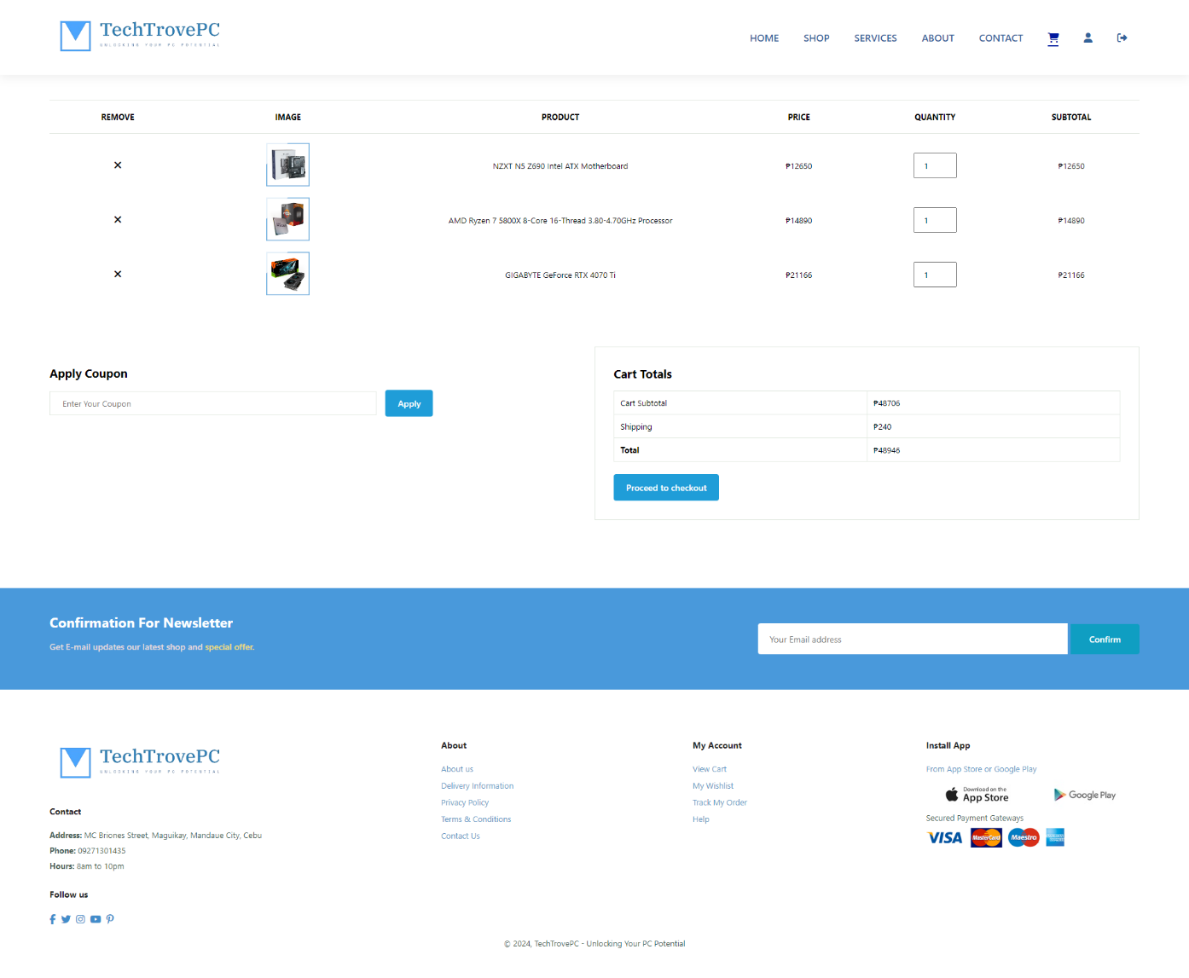

*Checkout Page*

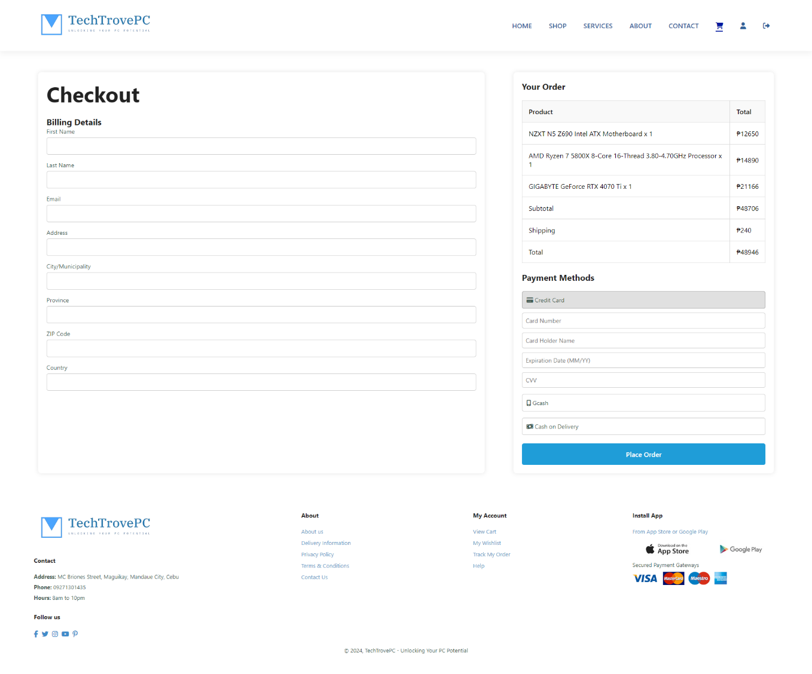

*Place Order Modal*

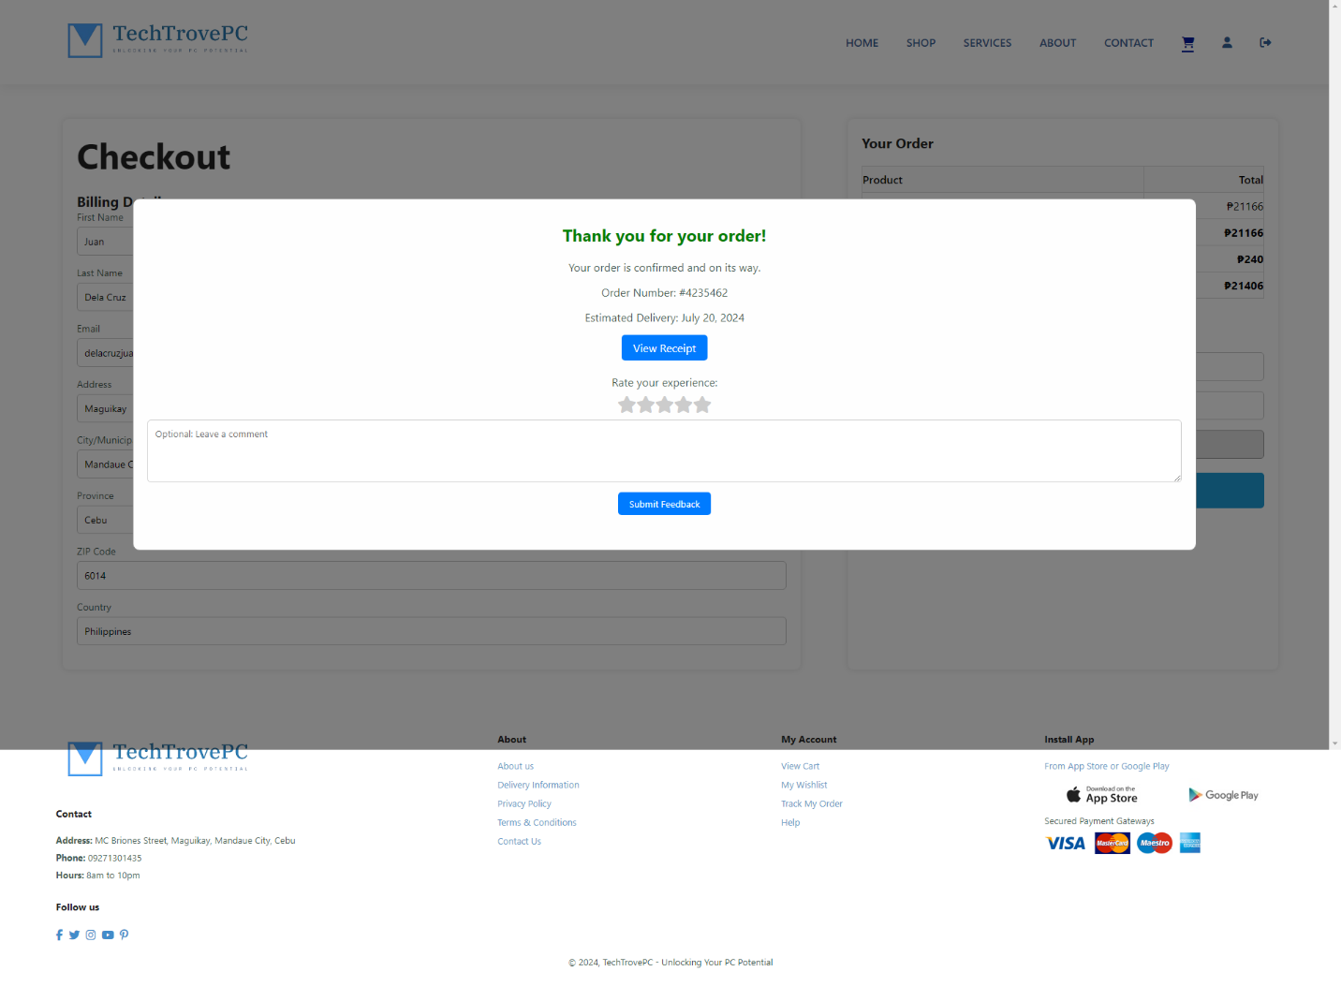

View Receipt

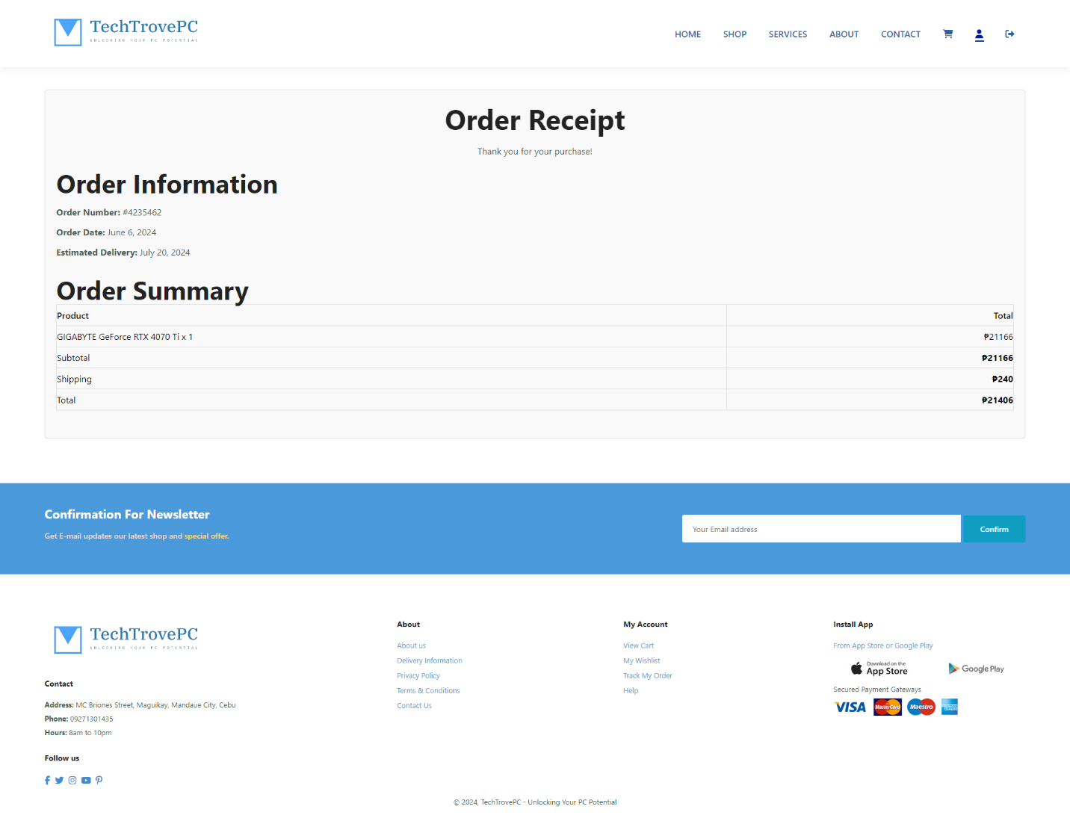

View Profile Page

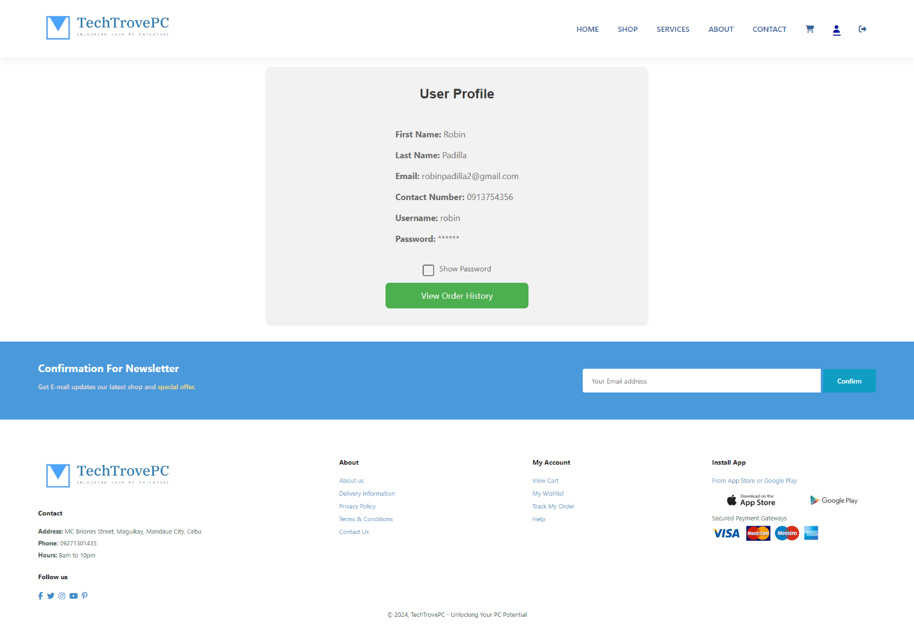

*My Purchases / Order History Page*

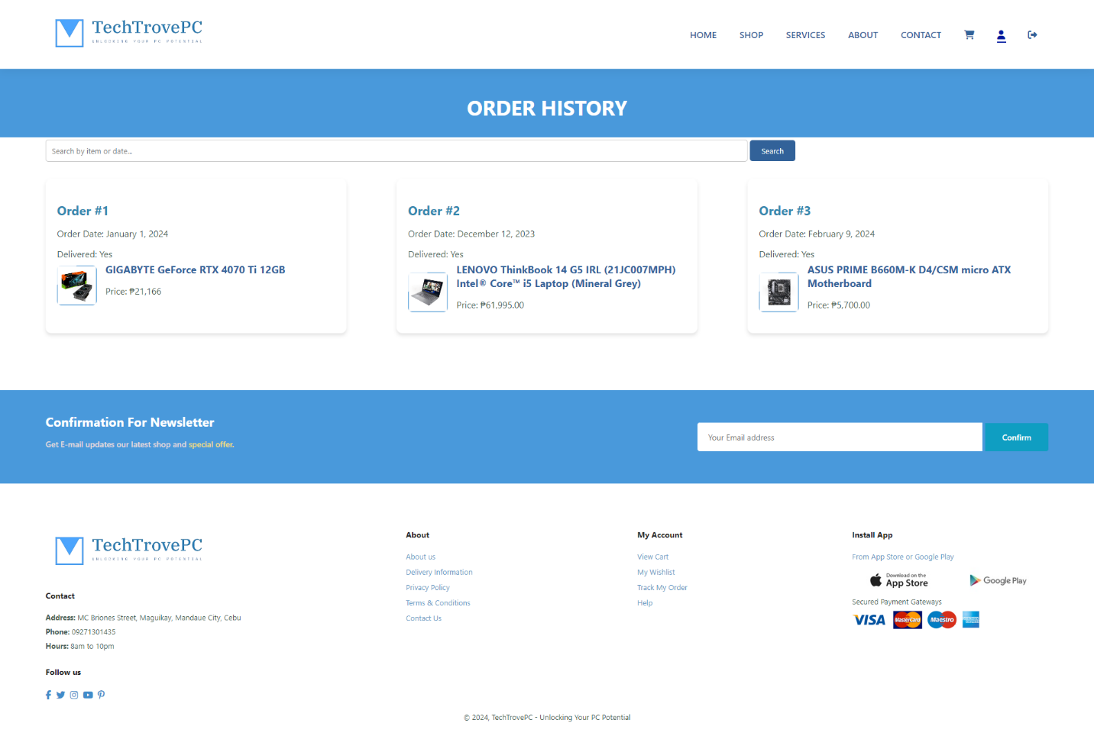

*Admin Dashboard*

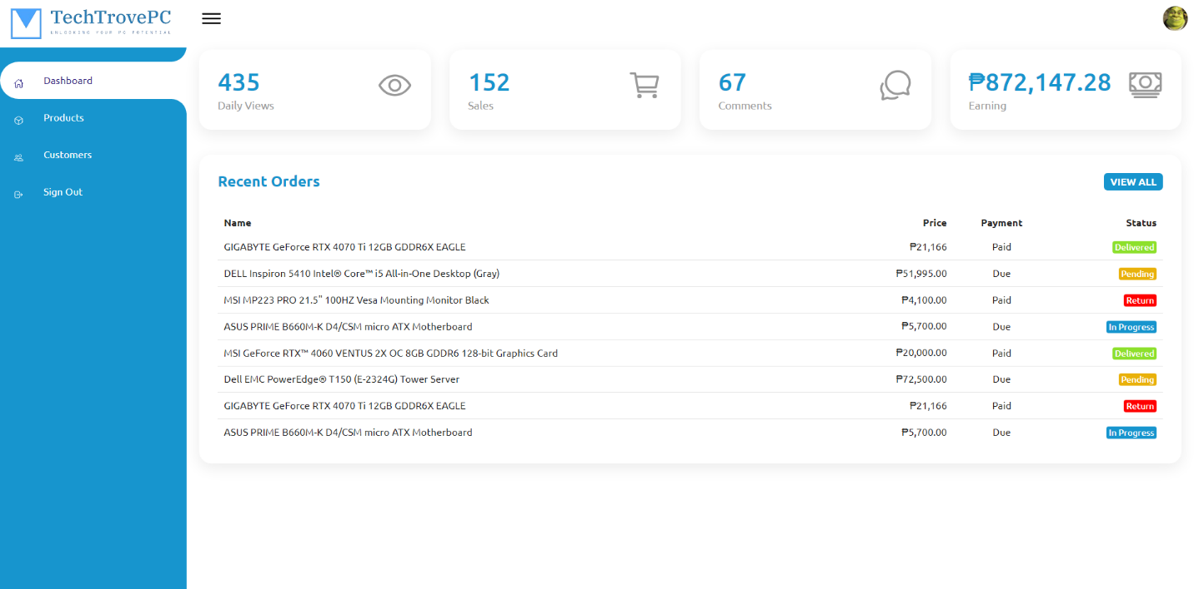

View Customer Status Page

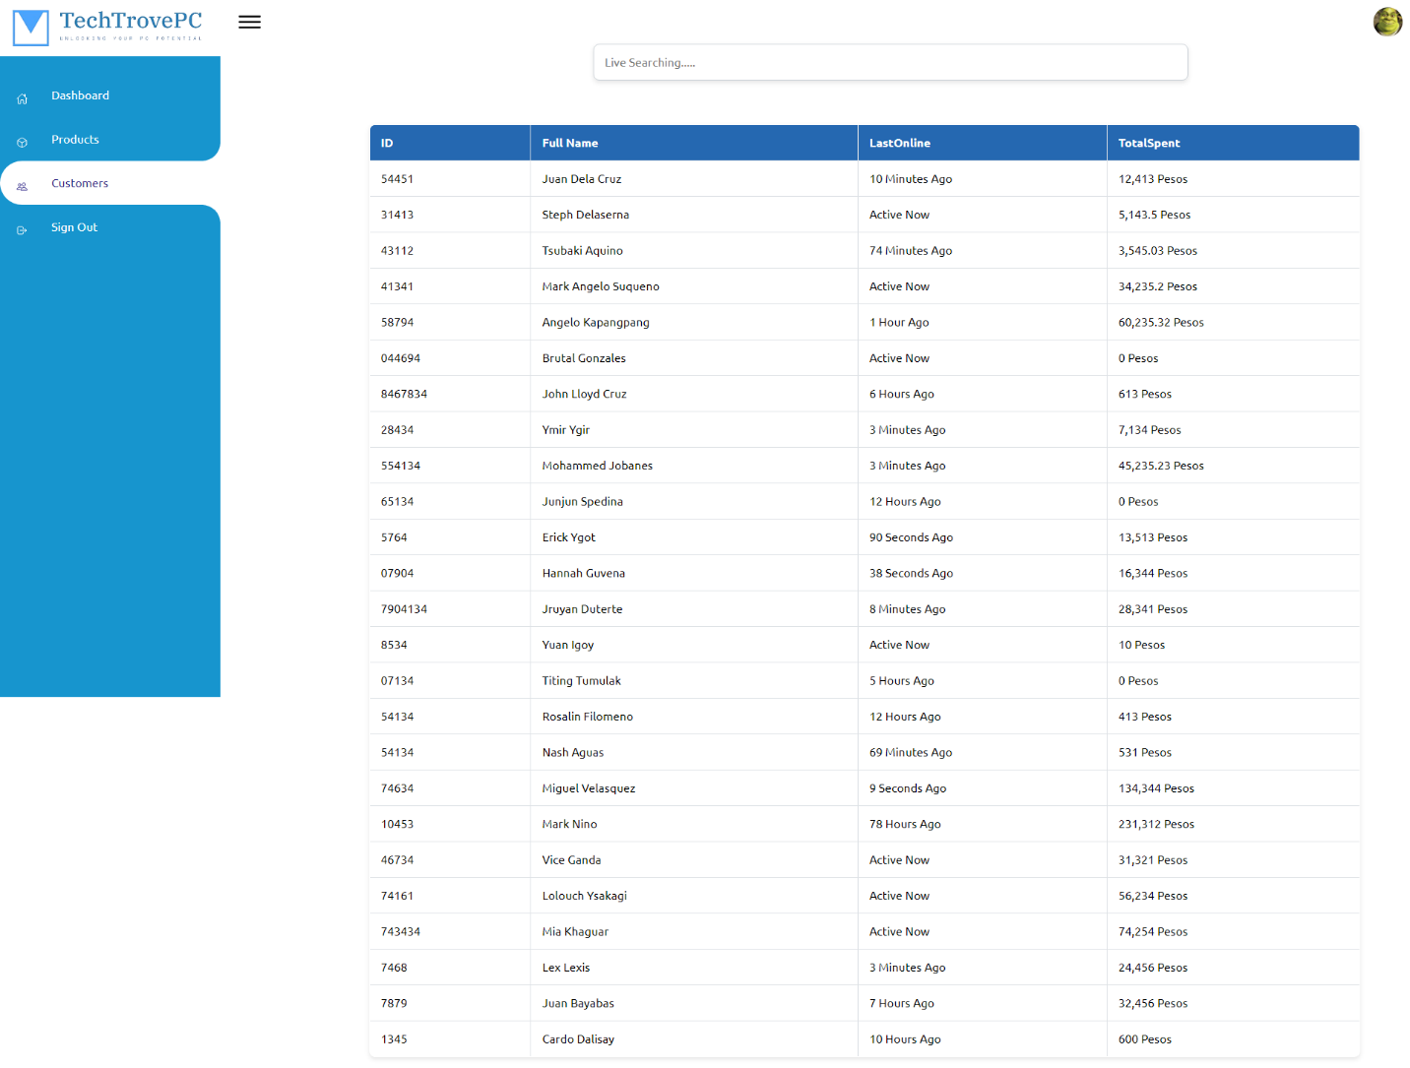

View Manage Products Page

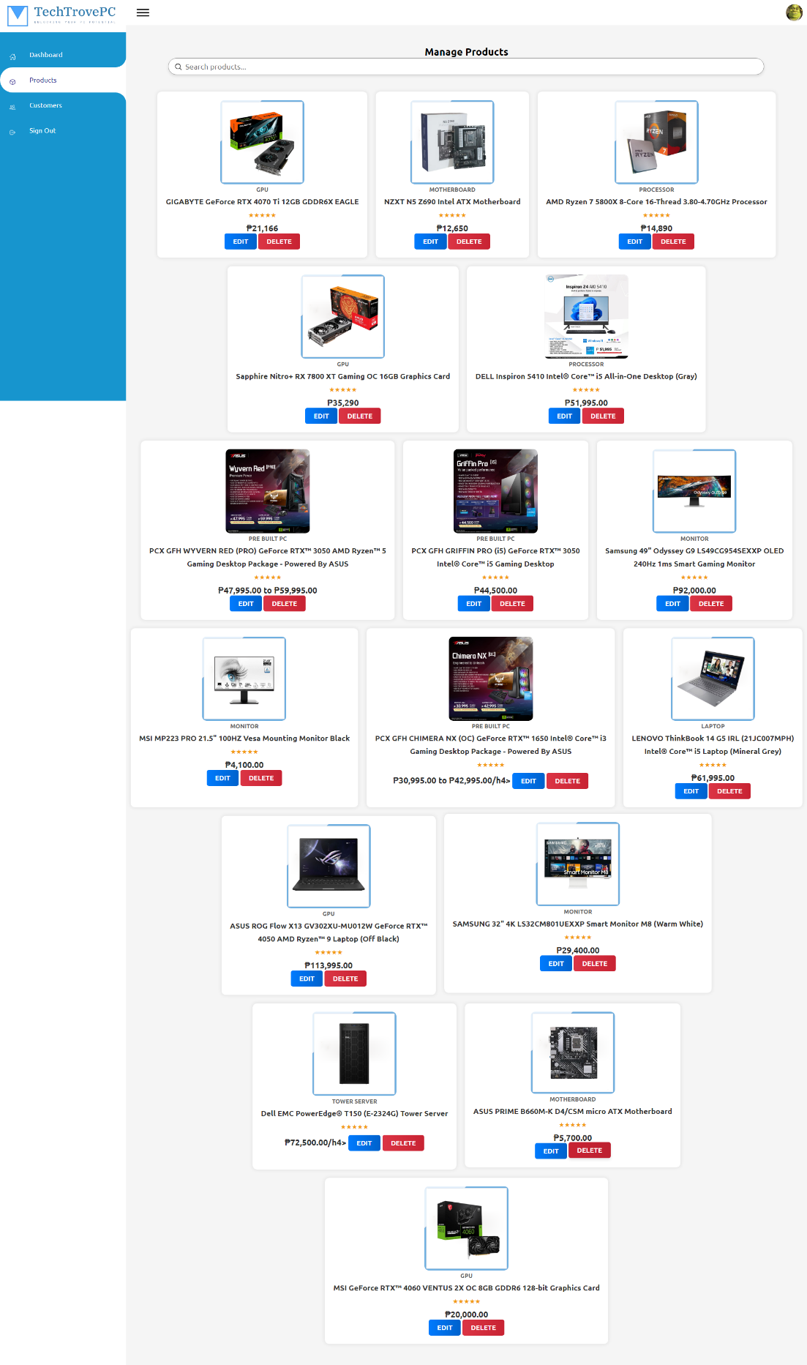

**TIME AND TASK MANAGEMENT**

|  |  |  |  |
| --- | --- | --- | --- |
| **NAME** | **ASSIGNED TO** | **PRIORITY** | **STATUS** |
| Christian Jake Alalim | WEBSITE CODING | HIGH | COMPLETED |
| Alnur Tuttuh | WEBSITE CODING | HIGH | COMPLETED |
| Cabrera Eda | DOCUMENTATION | HIGH | COMPLETED |
| Mark Segarra | SERVICES PAGE | HIGH | COMPLETED |
| Mica Villarta | WEBSITE DESIGN | HIGH | COMPLETED |
| Rence Galvez | DOCUMENTATION | HIGH | COMPLETED |

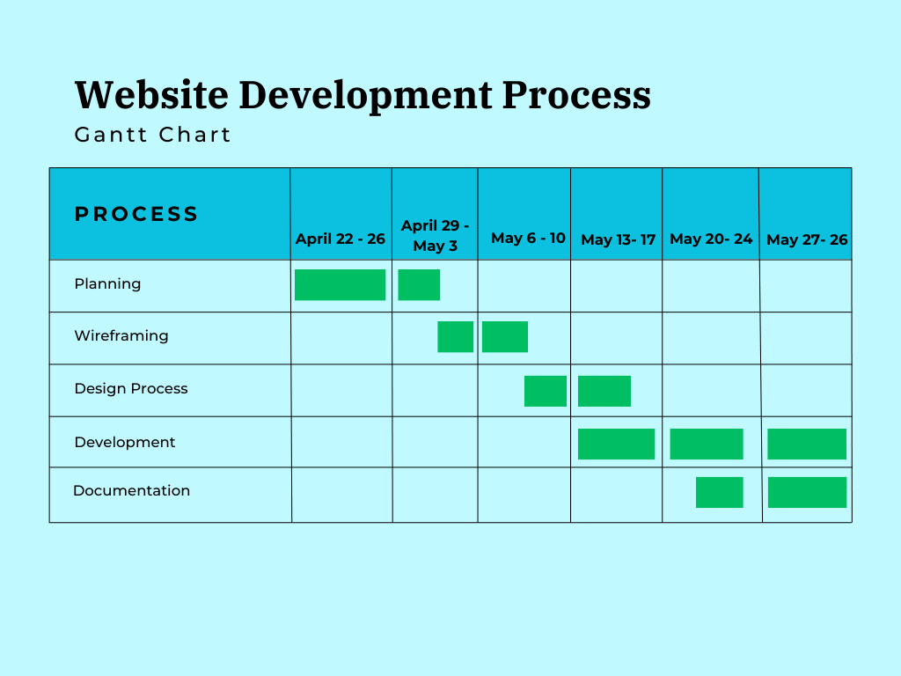

**LIMITATIONS**

There are some limitations in our current implementation. We focused on using HTML, CSS, and JavaScript for the front-end development of the website. This decision was based on our current level of expertise and the resources available to us. Here are some of the key limitations:

1. **No Back-End Integration**:
   * **Static Data Handling**: The website lacks a back-end server for dynamic data handling. As a result, product information, user data, and cart details are stored statically within the JavaScript code. Any changes to product listings or user data require manual updates to the code.
   * **No Database**: Without a back-end database, there is no persistent storage for user accounts, orders, or inventory. User data entered during login and sign-up is not retained beyond the session.
2. **Limited User Authentication and Security**:
   * **Basic Authentication**: The login and sign-up functionalities are implemented using simple JavaScript logic without secure authentication protocols. This limits the security of user credentials and personal information.
   * **No SSL/TLS Encryption**: The website does not implement HTTPS, which means data transmitted between the user and the website is not encrypted. This poses a security risk for sensitive information.
3. **Client-Side Only Functionality**:
   * **Local Storage**: The "Add to Cart" and "Proceed to Checkout" features rely on the browser's local storage. This means that cart data is only available on the specific device and browser where the items were added. Users cannot access their cart from different devices or browsers.
   * **Session Limitations**: User sessions are limited to the current browsing session. Once the browser is closed, all session data, including login status and cart contents, is lost.
4. **Scalability and Performance**:
   * **Static Website**: As a static website, TechTrovePC is not optimized for high scalability. Serving a large number of users simultaneously may lead to performance issues, such as slow loading times and unresponsive pages.
   * **Limited Interactivity**: While JavaScript provides some interactivity, complex functionalities and dynamic user interactions are constrained by the lack of a more powerful server-side framework.
5. **Lack of Advanced Features**:
   * **No Payment Gateway Integration**: The checkout process does not include real payment gateway integration. Users cannot complete actual transactions through the website.
   * **Limited Product Management**: The website does not support advanced product management features such as inventory tracking, real-time updates, or user reviews.
6. **Offline Only Operation**:
   * **No Deployment**: The website has not been deployed online and is currently accessible only through the index.html file, working offline. This means users cannot access the website via the internet, limiting its reach and usability.
   * **Local Environment**: All functionalities are tested and used in a local environment. This limits our ability to test the website under real-world conditions, including varying internet speeds and different user devices.

These limitations reflect the scope of our project as highschool students working with front-end technologies. Despite these constraints, we have successfully created a functional and visually appealing e-commerce platform. Future enhancements could include integrating back-end technologies, deploying the website online, improving security measures, and adding more advanced features to enhance the overall functionality and user experience of TechTrovePC.

**RESOLUTION**

We have outlined several potential resolutions that can be implemented in future iterations of the project. These resolutions aim to enhance the functionality, security, and overall user experience of the website.

1. **Back-End Integration**:
   * **Dynamic Data Handling**: Implementing a back-end server using technologies such as Node.js, Django, or Ruby on Rails will allow for dynamic data handling. This will enable real-time updates to product listings, user data, and cart details without manual code changes.
   * **Database Integration**: Incorporating a database system such as MySQL, PostgreSQL, or MongoDB will provide persistent storage for user accounts, orders, and inventory. This will allow users to retain their data across sessions and access their accounts from different devices.
2. **Enhanced User Authentication and Security**:
   * **Secure Authentication Protocols**: Implementing secure authentication protocols such as OAuth or JWT (JSON Web Tokens) will enhance the security of user credentials and personal information.
   * **SSL/TLS Encryption**: Enabling HTTPS on the website will ensure that all data transmitted between the user and the website is encrypted, protecting sensitive information from potential security threats.
3. **Improved Client-Side Functionality**:
   * **Session Management**: Utilizing cookies or session storage in combination with back-end sessions will allow for better session management. This will enable users to maintain their login status and cart contents even after closing the browser.
   * **Cross-Device Accessibility**: With a back-end server and database, users will be able to access their accounts and cart contents from different devices, improving the overall user experience.
4. **Scalability and Performance Enhancements**:
   * **Server-Side Rendering (SSR)**: Implementing SSR can improve the website's performance and scalability, providing faster load times and a better user experience, especially for users with slower internet connections.
   * **Content Delivery Network (CDN)**: Using a CDN will help distribute the website's static assets globally, reducing load times and improving performance for users worldwide.
5. **Advanced Features**:
   * **Payment Gateway Integration**: Integrating payment gateways such as PayPal, Stripe, or Square will enable users to complete actual transactions through the website, enhancing its e-commerce capabilities.
   * **Product Management System**: Developing an admin panel for product management will allow for real-time updates to inventory, pricing, and product details. This will also enable features such as user reviews and ratings.
6. **Online Deployment**:
   * **Web Hosting**: Deploying the website on a web hosting service such as Heroku, AWS, or Netlify will make it accessible via the internet, significantly expanding its reach and usability.
   * **Domain and SSL Certificate**: Acquiring a custom domain name and SSL certificate will ensure the website is professional and secure, building trust with users.

These improvements will not only make the website more robust and reliable but also prepare it for real-world deployment and use, allowing us to reach a broader audience and provide a superior e-commerce experience

**CONCLUSION**

The development of the TechTrovePC website has been a valuable and educational experience for IP22 Group 1. Through this project, we successfully created a functional and visually appealing e-commerce platform using HTML, CSS, and JavaScript. Our efforts focused on providing a smooth and engaging user experience for those seeking an electronic products, particularly desktops and laptops.

Despite the limitations we faced, such as the absence of back-end integration and the need for static data handling, we demonstrated our ability to work collaboratively and effectively manage our time and tasks. Our documentation outlined these challenges and provided resolutions that can be implemented in future iterations to enhance the website's functionality, security, and scalability. These areas, we can transform TechTrovePC into a more robust and user-friendly platform, capable of supporting dynamic data, secure transactions, and real-world deployment.

We are excited about the potential improvements and advancements we can make to TechTrovePC. The resolutions proposed will not only overcome the current limitations but also pave the way for a professional e-commerce solution. This project has laid a strong foundation for our skills in web development and project management, and we are confident that with continued learning and application of these skills, TechTrovePC can evolve into a highly competitive and successful e-commerce platform.

**DEFINITION OF TERMS**

* **Back-End Server:** A server that handles the data processing and storage required by a website. It is responsible for managing database operations, user authentication, and server-side logic.
* **Content Delivery Network (CDN):** A geographically distributed network of servers and their data centers. The goal is to provide high availability and performance by distributing the service spatially relative to end users.
* **CSS (Cascading Style Sheets):** A style sheet language used for describing the presentation of a document written in HTML. CSS controls the layout, colors, fonts, and overall visual appearance of web pages.
* **Database:** An organized collection of structured information, or data, typically stored electronically in a computer system. A database is controlled by a database management system (DBMS).
* **E-Commerce Website:** An online platform that allows users to buy and sell goods and services over the internet. E-commerce websites typically include features for product listings, shopping carts, payment processing, and customer accounts.
* **Front-End Development:** The practice of producing HTML, CSS, and JavaScript for a website or web application so that a user can see and interact with them directly. It involves the implementation of the visual and interactive aspects of a website.
* **HTML (HyperText Markup Language):** The standard language used to create and structure content on the web. HTML elements form the building blocks of web pages, providing the basic framework for websites.
* **JavaScript:** A programming language commonly used in web development to create interactive effects and dynamic content on websites. JavaScript allows developers to implement features such as form validation, interactive maps, and real-time updates.
* **JWT (JSON Web Token):** A compact, URL-safe means of representing claims to be transferred between two parties. The claims in a JWT are encoded as a JSON object that is used for secure transmission of information.
* **Local Storage:** A web storage mechanism that allows websites to store data on a user's browser. This data persists even after the browser is closed and reopened, unlike session storage.
* **OAuth (Open Authorization):** An open standard for access delegation commonly used as a way to grant websites or applications limited access to a user's information without exposing the user's password.
* **Payment Gateway:** A service that authorizes and processes payments for e-commerce websites. Payment gateways securely transfer payment information between the website, the customer, and the bank.
* **Server-Side Rendering (SSR):** A method of rendering web pages on the server rather than in the browser. SSR improves the performance and speed of web applications by generating the HTML content on the server.
* **Session Storage:** Similar to local storage, but the data is cleared when the page session ends. This means data is only available while the browser tab is open and is cleared once the tab is closed.
* **SSL/TLS (Secure Sockets Layer/Transport Layer Security):** Cryptographic protocols designed to provide communications security over a computer network. HTTPS is the use of SSL/TLS to secure the data between the user's browser and the website.
* **TechTrovePC:** The name of the e-commerce website developed by IP22 Group 1, specifically designed to offer high-quality electronic products, particularly desktops and laptops, to tech enthusiasts and everyday users.
* **User Experience (UX):** The overall experience of a person using a product such as a website or computer application, especially in terms of how easy or pleasing it is to use. UX design involves enhancing user satisfaction by improving the usability, accessibility, and pleasure provided in the interaction with the product.
* **User Interface (UI):** The space where interactions between humans and machines occur. The goal of this interaction is effective operation and control of the machine from the human end, while the machine simultaneously provides feedback that aids the operators' decision-making process.
* **Web Hosting:** A service that allows individuals and organizations to make their website accessible via the World Wide Web. Web hosts provide space on a server owned or leased for use by clients.

**REFERENCES**

Atlassian. (n.d.). Project management basics. Retrieved from https://www.atlassian.com/project-management

Auth0. (n.d.). What is JSON Web Token?. Retrieved from https://auth0.com/learn/json-web-tokens/

BigCommerce. (n.d.). E-commerce website development guide. Retrieved from https://www.bigcommerce.com/ecommerce-website-development/

Cloudflare. (n.d.). What is a CDN?. Retrieved from https://www.cloudflare.com/learning/cdn/what-is-a-cdn/

GoDaddy. (n.d.). What is web hosting?. Retrieved from https://www.godaddy.com/hosting/web-hosting

Google Developers. (n.d.). Web fundamentals. Retrieved from https://developers.google.com/web/fundamentals

IBM. (n.d.). What is a database?. Retrieved from https://www.ibm.com/cloud/learn/database

Interaction Design Foundation. (n.d.). User interface (UI) design. Retrieved from https://www.interaction-design.org/literature/topics/ui-design

MDN Web Docs. (n.d.). CSS: Cascading Style Sheets. Retrieved from https://developer.mozilla.org/en-US/docs/Web/CSS

MDN Web Docs. (n.d.). Frontend development. Retrieved from https://developer.mozilla.org/en-US/docs/Learn/Front-end_web_developer

MDN Web Docs. (n.d.). HTML: HyperText Markup Language. Retrieved from https://developer.mozilla.org/en-US/docs/Web/HTML

MDN Web Docs. (n.d.). JavaScript. Retrieved from https://developer.mozilla.org/en-US/docs/Web/JavaScript

MDN Web Docs. (n.d.). Server-side website programming. Retrieved from https://developer.mozilla.org/en-US/docs/Learn/Server-side

MDN Web Docs. (n.d.). Window.localStorage. Retrieved from https://developer.mozilla.org/en-US/docs/Web/API/Window/localStorage

MDN Web Docs. (n.d.). Window.sessionStorage. Retrieved from https://developer.mozilla.org/en-US/docs/Web/API/Window/sessionStorage

Nielsen Norman Group. (n.d.). User experience basics. Retrieved from https://www.nngroup.com/articles/definition-user-experience/

OAuth.net. (n.d.). OAuth 2.0. Retrieved from https://oauth.net/2/

PayPal. (n.d.). What is a payment gateway?. Retrieved from https://www.paypal.com/us/brc/article/what-is-a-payment-gateway

Shopify. (n.d.). How to build an e-commerce website. Retrieved from https://www.shopify.com/blog/ecommerce-website

SSL Labs. (n.d.). SSL/TLS deployment best practices. Retrieved from https://www.ssllabs.com/projects/best-practices/

Trello. (n.d.). Project management guide. Retrieved from https://trello.com/en/guide/project-management

Vercel. (n.d.). Server-side rendering. Retrieved from https://vercel.com/docs/concepts/rendering/server-side-rendering

W3C. (n.d.). Web accessibility initiative (WAI). Retrieved from https://www.w3.org/WAI/